**Keypad_interfacing basics:**

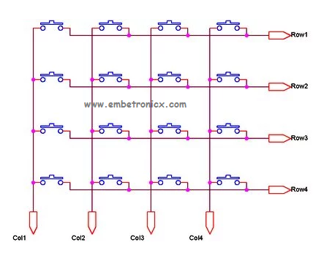

Configured as output .Logic zero is given primarily

Pulled up- primarily in HIGH state – configured as input

1. A logic LOW is given to Row1 and others (Row2 – Row-4) HIGH
2. Now each Column is scanned. If any switch belongs to the 1st row is pressed the corresponding column will pull down (logic LOW) and we can detect the pressed key.
3. This process is repeated for all rows.